Virtual Control Laboratory with Graphical User Interface
Description
System modelling and simulation are fundamental in industrial Research & Development. A proposed engineering solution can be tested and challenged via simulation, hence improved step by step in a development cycle, before putting it in into practice and building a real prototype: this allows for a substantial cost reduction in the R&D process. In particular, to design a controller ensuring that a physical system exhibits the desired behaviour, first a suitable model of the system must be built, to enable analysis and simulation. Once a control strategy has been devised, it is important to try it out and check through simulations if the controlled system behaves as desired. Then, after accurate virtual tests, it is possible to actually implement the controller and perform real tests on the physical controlled system. This procedure goes under the name of Model-Based Design.
For students learning how to design control strategies, it would be crucial to have a Virtual Control Laboratory, where they could (i) interact with simulated models that virtualise classical lab processes, (ii) implement a controller and (iii) check its performance on the simulated system in real time.
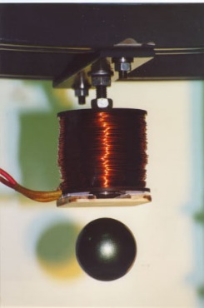
The aim of this BSc project is to build a Virtual Control Laboratory graphical user interface with several Virtual Experiments, each displaying the behaviour of a dynamical system and allowing the user to design a control law and see the effect of enforcing it in simulation. Possible Virtual Experiments can feature:
- two/three-tank hydraulic system (fluid dynamics);
- inverted pendulum, cart-pendulum system, ball and beam, oscillating flywheel, vibrating building, robotic arm (mechanical systems);
- DC motor and magnetic levitator (electromechanical systems);
- vehicle dynamics (for path planning and cruise control);
- airplane / helicopter / quadrotor flight simulator.
We are looking for motivated students that like to be challenged and have a keen interest in mathematical models and in the development of an integrated simulator with a graphical user interface, relying on the use of professional software like Matlab. The students are required to: implement a collection of models in Matlab and, for each, develop a graphical user interface that visualises the system evolution in real time, starting from an initial condition assigned by the user, both without control and with a control strategy decided by the user. Students are encouraged to express their creativity in the design of the interface and to suggest more models to be implemented. The development of the Virtual Control Laboratory will provide a nice tool for teaching and learning control with a hands-on approach, suitable to be used in control courses at TU Delft and in other universities.
Department
Delft Center for Systems and Control (DCSC)
Supervisor
Dr. Giulia Giordano G.Giordano@tudelft.nl Delft Center for Systems and Control (DCSC)

